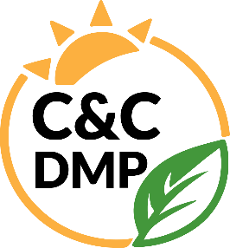
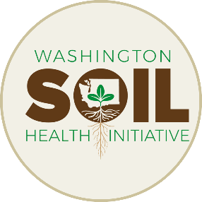
Data Management Plan
WSDA’s Climate & Conservation Team
Jadey Ryan
Dani Gelardi
2026-01-06
Table of contents
Overview 3
Chapter outline 3
Roles and responsibilities 4
Staff turnover 4
Acknowledgements 5
1. What is data management? 6
1.1 Data life cycle 6
2. Formats & standards 8
2.1 Data formats 8
2.2 Data standards 10
3. Naming conventions 11
3.1 Why are conventions important? 11
3.2 Best practices 11
3.3 Naming examples 15
4. Organization 16
4.1 Folder structure 16
4.2 Archive folders 17
4.3 Code-based project organization 17
5. Storage & version control 18
5.1 Backup 18
5.2 Read-only raw data 19
5.3 Version control with Git and GitHub 19
6. Documentation 22
6.1 Project-level 22
6.2 Dataset-level 23
6.3 Variable-level 24
6.4 External data 25
7. Data flow 26
7.1 Pre field season 26
7.2 During field season 28
7.3 Post field season 28
8. Data sharing 30
8.1 WaTech data categorization 30
8.2 Maintain confidentiality 31
8.3 Data share agreement 31
8.4 Public access 32
8.5 Acknowledgments 32
9. Code style guide 33
9.1 Projects 33
9.2 Naming conventions 35
9.3 R scripts 37
9.4 Code styling 40
References 42

Overview
 Tip
View this data management plan as an online book at https://wa-department-of-agriculture.github.io/washi-dmp/.
The Washington Soil Health Initiative (WaSHI) is a partnership between the Washington State Department of Agriculture (WSDA), Washington State University (WSU), and the State Conservation Commission that establishes a coordinated approach to healthy soils in Washington. Within WSDA, this work is led by the Climate & Conservation Team, which supports a growing portfolio of soil health, conservation, and climate-focused programs and projects.
This data management plan (DMP) applies to data generated and managed by the Climate & Conservation Team across multiple initiatives, including the Voluntary Stewardship Program, Saving Tomorrow’s Agriculture Resources, Nitrate Leaching Reduction, Livestock Composting, and related climate and conservation efforts.
The DMP originally was developed to support the State of the Soils Assessment (SOS), a statewide soil health monitoring program that collected nearly 1,200 soil samples and management surveys across 66 different cropping systems and all 39 counties in Washington. Following the conclusion of this effort, this DMP has been revised to support the broader range of projects led by the Climate & Conservation Team.

Chapter outline
This DMP is a living document to be continually reviewed and improved based on lessons learned, new information, and collaborator feedback.
Chapter 1 describes what data management is, why it is crucial to achieve our data-driven goals, and how our data move through the data life cycle.
Chapter 2 describes the various data formats we collect and manage. ISO standards are also described for date and geospatial data.
Chapter 3 describes naming conventions, best practices, and examples for how we name folders and files.
Chapter 4 describes how we organize our folders into a hierarchical structure.
Chapter 5 describes where we store data, what our backup policies are, how we protect our raw data, and how we use version control.
Chapter 6 describes how we record each element of the data life cycle with project-level, dataset-level, and variable-level documents such as standard operating procedures, readme files, data dictionaries, etc.
Chapter 7 describes how data are generated, processed, and moved from start to finish. Processes and tasks are grouped by pre, during, and post field season.
Chapter 8 describes how we protect producer privacy; how our data fits into WaTech data categories; requirements and processes for maintaining confidentiality; and our data share agreement, public access policies, and our preferred acknowledgements.
Chapter 9 describes our recommended project structures, code-specific naming conventions, script structures, and code style.
 Links to shared drive folders and files
This DMP includes many links to folders and files on the shared drive, which are only accessible to WSDA staff on the state network or remotely connected using VPN.
 GitHub links
If you are not logged into a GitHub account that is part of the WSDA organization or has access to the washi-sos repository, GitHub links to specific scripts will take you to a 404 not found error page.

Roles and responsibilities
To maximize the benefits of effective data management, all WSDA personnel who interact with Climate & Conservation Team data must familiarize themselves with this DMP.
The Data Scientist, supported by the Senior Soil Scientist, is responsible for providing guidance to staff working with data and ensuring the implementation of this DMP. The Data Scientist is also responsible for reviewing and updating this document annually, and as needed. Upon updates, the Data Scientist will distribute this document to staff and commit the source code to the GitHub repository.

Staff turnover
When staff leave, they take their skills, institutional knowledge, and personal understanding of their file management with them. Proper offboarding is essential to ensure knowledge isn’t lost, time isn’t wasted trying to recreate workflows, and projects keep moving.
Before the employee leaves, the Senior Soil Scientist and Data Scientist ensure that:
- Folders and files are moved from the employee’s personal drive to the shared drive. They are named and organized according to Chapter 3.
- Workflows and specific processes the employee was responsible for are well documented.
- Permission and ownership for the following are transferred to the appropriate remaining staff:
  - GitHub WSDA organization
  - ArcGIS data products and online groups
  - Database credentials
  - Box.com folders
More resources and off boarding checklists from Harvard Research Data Management can be found in our data-management shared drive.

Acknowledgements
This DMP was adapted from the R.J. Cook Agronomy Farm Long-Term Agroecological Research Site DMP (Carlson 2021), U.S. Fish and Wildlife Service data management life cycle (U.S. Fish & Wildlife Service 2023), Harvard Medical School Longwood Research Data Management DMP guidelines (Harvard Medical School 2023), and the Data Management in Large-Scale Education Research book (Lewis 2023).

1. What is data management?
Effective data management involves properly documenting, storing, and sharing data and information derived from the data. If the data aren’t usable by researchers, policymakers, or growers, then all the time, energy, and effort spent collecting and analyzing the samples may be wasted.
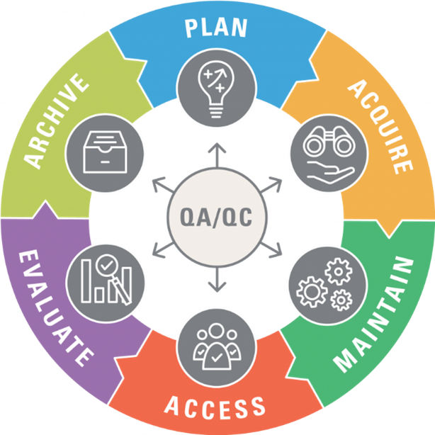
The guidelines detailed in this DMP help us achieve our data-driven goals, while also optimizing the value of the data by supporting information sharing and innovation. Our data management policies aim to implement FAIR (Findable, Accessible, Interoperable, Reusable) principles while also maintaining data privacy (Wilkinson et al. 2016).

1.1 Data life cycle
This graphic explains the data life cycle (U.S. Fish & Wildlife Service 2023), in which each step requires care to ensure transparency, quality, and integrity.
Our adaptation is outlined below and the following chapters detail our internal processes and standards to follow throughout each step in the data life cycle.
 | Plan  Planning includes decisions about data acquisition, management, and quality control, as well as regular examinations of ways to improve. For example, each year we provide an updated spreadsheet template to Soiltest lab to ensure that measurements are reported with correct units and in the correct format. Special projects that deviate from our standard operating procedures require additional planning.
 | Acquire  We acquire data by collecting and analyzing new samples, deriving new insights from existing samples, or accepting datasets from collaborators.
 | Maintain  Maintenance involves processing data for aggregation, analyses, and reporting. We create metadata that facilitates interpretation of the data. We also store a copy of our data in a format that is accessible to our collaborators and future selves.
 | Access  Access refers to data storage, publication, and security. Raw and processed data with accompanying metadata should be stored, backed up, and available for information sharing with our partners. With Senior Soil Scientist approval, anonymized and aggregated data that does not compromise growers’ personally identifiable information can be made publicly available in a data repository or data product/decision-support tool.
 | Evaluate  We evaluate data while processing and analyzing it to maximize accuracy and productivity, while minimizing costs associated with errors or tedious data cleaning labor. Evaluation workflows should be efficient, well-documented, and reproducible. Our evaluated data help us better understand how environmental factors and management decisions impact soil health.
 | Archive  Properly archiving our results supports the long-term storage and usefulness of our data. While similar to the Access element of the life cycle, archiving focuses on preserving data for historical and long-term access. For example, we archive each year’s raw data for long-term storage and set those files to Read-Only.
 | Quality Assurance / Quality Control (QA/QC)  Data quality management prevents data defects that hinder our ability to apply data towards our science-based conservation efforts. Defects include incorrectly entered data, invalid data, and missing or lost data. QA/QC processes should be incorporated in every element of the data life cycle.

2. Formats & standards

2.1 Data formats
Data generated from or integrated into Climate & Conservation work can be non-digital or digital.

Non-digital data
Non-digital data, such as field forms, management surveys, and chain of custody forms, are manually recorded on paper forms. Paper forms must be transcribed or converted to digital file formats and then stored in the WaSHI filing cabinet in the Natural Resources Building in Olympia.

Digital data
Digital data include tabular, spatial, and binary data, such as lab results, sample locations, and field photos. Non-conventional data also include code, algorithms, tools, and workflows.
Tabular data include comma separated values (csv), tab separated values (tsv), Microsoft Excel open XML spreadsheet (xlsx), and portable document format (pdf).
Spatial data include file geodatabases (gdb), vector shapefiles (zipped folder containing multiple file extensions), keyhole markup language (kml or kmz). Tabular data may also contain spatial data such as longitude and latitude.
Binary data include photos (jpeg, png, gif, tiff), videos (mp4), code (R, py, js), and object-oriented data files (RDS, Rdata, parquet, arrow).
Proprietary data formats include Microsoft Excel, Word, and Powerpoint files (xlsx, docx, pptx). RDS and RData files are examples of application-specific data formats that can only be opened using the R programming language or RStudio IDE. These types of files should be saved in conjunction with a copy of the data in a non-proprietary and open-standard format, such as csv, to maintain accessibility for those who do not have Microsoft Office or do not use R.
Written documents and presentations are in formats including Microsoft Word and PowerPoint (docx and pptx), hypertext markup language (HTML), and pdf.
Notebooks combine text with executable code to generate written documents and presentations in docx, pptx, html, or pdf formats. These notebooks are stored in formats depending on the programming language: a couple examples include Quarto (qmd) and Jupyter notebook (ipynb).

The list below is not exhaustive and will continue to grow as additional data sources are discovered.
Type | Source | Formats
Lab results | Provided by an analytical lab, study PI, or grower | csv, xlsx, pdf, xml, json, RDS, RData
Management surveys | Collected through interviews with grower | csv, xlsx, RDS, RData, scanned paper form
Field forms | Completed in the field during/immediately after sampling | pdf, scanned paper form, csv, xlsx
Sample locations | Identified prior to sampling using ArcGIS Online and updated while sampling using ArcGIS Field Maps | ArcGIS feature layer, shp, kmz, csv, xlsx
Chain of custody forms | Completed prior to shipping or dropping off samples | pdf, scanned paper form
Climate data | OSU PRISM, NOAA, Esri Living Atlas | csv, shp, netCDF, tiff, gdb
Soil data | NRCS Web Soil Survey, NRCS WA gSSURGO | gdb, accdb
Images | Logos, icons, photos taken in the field | jpeg, png, gif, tiff, svg
Videos | Recordings of meetings, training videos | mp4
Documents | Reports, manuscripts, SOP, QAPP, factsheets, brochures | docx, txt, html, pdf
Presentations | PowerPoints, slide decks | pptx, html, pdf
Code | Scripts for wrangling and analyzing data; markdown for documents and presentations; style sheets for html | R, py, ipynb, js, yml, rmd, qmd, css, scss

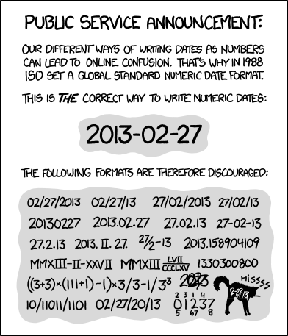
ISO 8601, Randall Munroe’s xkcd

2.2 Data standards
Date will be expressed as YYYY-MM-DD according to ISO 8601 standard.
Date with time will be expressed as YYYY-MM-DDTHH:MM:SSZ.
- T separates date from time.
- Z designates the time zone (Z or -HH:MM).
  - Z if using Universal Time Coordinated (UTC) with no offset.
  - Pacific Standard Time (PST) offset is -8:00.
YYYY-MM-DDTHH:MM:SS-8:00
  - Pacific Daylight Time (PDT) offset is -7:00.
YYYY-MM-DDTHH:MM:SS-7:00

Geospatial data will be accompanied by metadata that abides by the ISO 19115 standard and follows Esri’s documentation when using ArcGIS Pro. Metadata contains information about the identification, extent, quality, spatial and temporal schema, spatial reference, and distribution of digital geographic data.
Code will follow the style guide in Chapter 9.

3. Naming conventions
When naming folders and files, use consistent and clear names that are findable and understandable by both humans and computers. A file name should convey what it contains and which file is the most recent version.
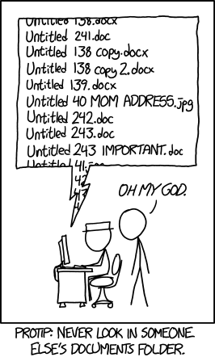
Documents, Randall Munroe’s xkcd

3.1 Why are conventions important?
- Improves consistency and predictability, making it easier to browse folders and know what they contain.
- Enables sorting files by date, conservation district, or another theme.
- Facilitates collaboration so all team members can find the information they need.
- Standardizes file paths and URLs for efficient programming and website hosting.
  - URLs and programming languages are case-sensitive. WaSHI-data.csv and washi-data.csv are completely different files.
  - URLs cannot have spaces in them. They must be escaped with this character entity %20. For example, wasoilhealth.org/producer spotlights would need to be wasoilhealth.org/producer%20spotlights.
For more web-specific naming conventions, see this Learn the Web webpage.

3.2 Best practices
Some files and folders in our shared drive do not follow these best practices or naming conventions. We are learning and improving as we go.
These are just guidelines. Because naming things is hard, we only ask that you try your best. If you’re unsure about names or need to rename externally named files in bulk, the Data Scientist can support you.
See Section 3.3 for a table of examples of folder and file names following these best practices.

Meaningful name casing
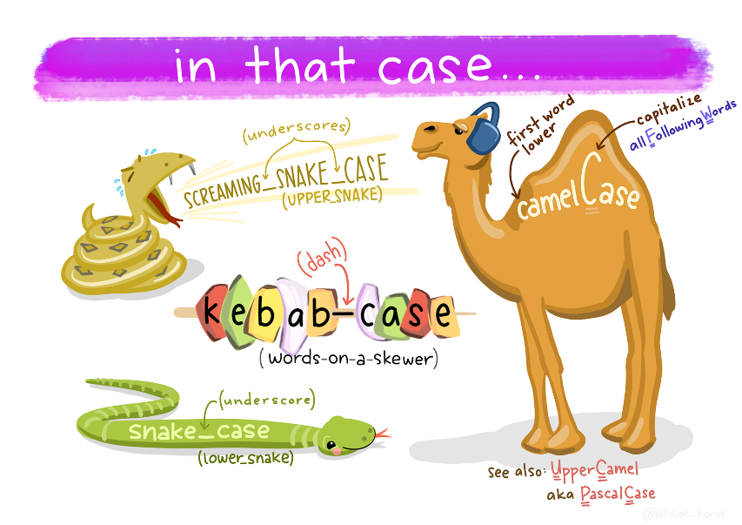
Artwork by Allison Horst
Different conventions work for different purposes (folders and files versus programming objects).
- kebab-case: all lowercase with hyphens separating words. Use for folders and files.
- snake_case: all lowercase with underscores separating words. Only use for column names in spreadsheets and code, such as functions and variables in R. See Section 9.2.3.1 for example R errors when including hyphens in object names.

Delimiters convey meaning
Deliberately use underscores and hyphens so we can easily understand the contents and programmatically parse file and folder names.
- Use underscores to delineate metadata elements (i.e. date from name from version date_name_version).
- Use hyphens to separate parts of one metadata element (i.e. date YYYY-MM-DD or name wsda-washi-presentation).

No spaces or special characters
Avoid spaces and special characters (only use underscores and hyphens). Characters like / () ! ? % + " ' have special meaning to computers and can break file paths and URLs.

Character length matters
Computers are unable to read file paths and file names that surpass a certain character length. Be concise AND descriptive. Omit prepositions and articles when possible. Abbreviate long words. The path limit on Windows is 260 characters.

‘Back to front’ date
Express date ‘back to front’ like YYYY-MM-DD according to the ISO 8601 standard. Left pad single-digit months and days with zeros to maintain chronological order of records when sorting alphanumerically.
✅ Do this | ❌ Don’t do this
2020-05-28_agenda.pdf | 2-14-2023_Agenda.pdf
2023-01-01_agenda.pdf | 2023-Jan-1_Agenda.pdf
2023-02-14_agenda.pdf | Dec052020_Agenda.pdf
2023-12-05_agenda.pdf | May_28_2020_Agenda.pdf

Group & sort files by name
Consider how folders and files should be grouped and sorted, and include appropriate metadata at the beginning of file names. By default, list the date first unless another structure better supports file access. The table below shows an example folder organized by date first (left) and by conservation district first (right).
Sort by date | Sort by district
2023-05-01_cowlitz_coc.pdf | cowlitz_coc_2023-05-01.pdf
2023-05-01_cowlitz_tracking.pdf | cowlitz_coc_2023-05-23.pdf
2023-05-09_ferry-cd_tracking.pdf | cowlitz_tracking_2023-05-01.pdf
2023-05-10_ferry-cd_coc.pdf | ferry-cd_coc_2023-05-10.pdf
2023-05-17_ferry-cd_coc.pdf | ferry-cd_coc_2023-05-17.pdf
2023-05-23_cowlitz_coc.pdf | ferry-cd_coc_2023-06-06.pdf
2023-06-06_ferry-cd_coc.pdf | ferry-cd_tracking_2023-05-09.pdf

Version numbers
Including the date in the file name is one way to version a file. Alternatively, or in addition to, append a version number. Consider how many possible versions there might be. If more than 10, use leading zeros so the numbers have the same length. v1 through v15 will not sort the same way as v01 through v15.
✅ Do this | ❌ Don’t do this
sop_v01.pdf | SOP_v1.pdf
sop_v02.pdf | SOP_v10.pdf
… [v03 - v09] | SOP_v11.pdf
sop_v10.pdf | SOP_v2.pdf
sop_v11.pdf | … [v3 - v9]

Collaboration
Add your initials to the end of the file name when “saving as” a file that multiple people are working on (i.e., 2023_sop-soil-health-monitoring_lm-jr.docx). This ensures a version is kept as a backup. Alternatively, use Track Changes if working in a MS Word document.

Literature and references
When saving journal articles, user guides, and other reference materials, use the convention author_year_abbreviated-title. Use underscores to separate different metadata (i.e., author, year, and title).
✅ Do this | ❌ Don’t do this
lal_2004_soil-c-to-mitigate-cc.pdf | lal-2004-soil-c-to-mitigate-cc.pdf
clark-et-al_2020_pmn-sampling | clark-et-al_2020_pmn-sampling

Column names and code
Naming conventions for data column headers differ from folders and files. The hyphens in kebab-case cause errors in R and SQL code. Additionally, hyphens, spaces, and other special characters are invalid for ArcGIS table and field names.
Use snake_case for column names in spreadsheets and code objects (R vectors, lists, dataframes, and functions).
In variable or parameter names, include the measurement with the unit. This prevents unit confusion and reduces the risk of misinterpreting or inappropriately using the data.
Do not use special characters. Instead of toc_%, use toc_percent.
 Note
The code naming convention here applies primarily to R. Python and other programming languages have different conventions.
See Chapter 9 for more details in the code style guide.

3.3 Naming examples
 | Naming convention | Examples
Folders | kebab-case | 2024_sampling  data-management
Files | kebab-case | 2023-11-15_survey-perennial.xlsx  2024-03_washi-newsletter-wsda-sos.docx  geisseler-et-al_2019_ace-protein.pdf  washi-logo-color.png  washi-dmp.Rproj  01_load-metadata.R  2024_producer-report.qmd
Column Names & Code | snake_case | sample_id  pmn_lb_ac  crop_summary  assign_quality_codes()

4. Organization
Folders are organized into a hierarchical structure to clearly delineate project components, improve searchability, and support reproducible workflows over time.

4.1 Folder structure
An effective folder structure balances depth and simplicity. Shallow structures can become cluttered and difficult to search, while overly deep structures require excessive clicking to navigate to a specific file. When a folder contains many subfolders, standalone files should be minimized or grouped into clearly labeled subfolders to reduce visual clutter and improve findability.
Y:/NRAS/soil-health-initiative is the parent folder for all WaSHI content.
The SOS folder structure uses a combination of date-based (year-specific subfolders) and categorical-based (datasets and documentation that span multiple years) organization. This structure is well suited for long-term projects that generate data over multiple years. Shorter-term or special projects may instead follow a single-year structure.
Y:/NRAS/soil-health-initiative/state-of-the-soils/
├── _complete-dataset
├── 2019_scbg
├── 2021_sampling
├── 2022_sampling
├── 2023_sampling
├── 2024_sampling
├── data-sharing
├── data-sources
├── maps
├── projects
├── qapp
├── sop
├── training-videos
├── equipment-inventory.xlsx
├── archived-sample-inventory.xlsx
└── sos-impacts.xlsx
Within each year-specific folder, subfolders are used to separate planning materials, forms, data, and workflows, supporting consistent and reproducible processes across sampling years. The 2023_sampling folder below provides an example:
Y:/NRAS/soil-health-initiative/state-of-the-soils/2023_sampling/
├── applications
├── coc
├── equipment
├── field-forms
├── forms
├── gis
├── lab-data
├── labels
├── management-surveys
├── public-docs
├── purchases
├── reports
├── sample-id-assignments
├── scripts
├── 2023-data-tracking.xlsx
└── 2023_post-season-wrap-up.docx

4.2 Archive folders
When too many drafts or versions clutter a subfolder, create a new folder with the naming convention of archive-folder-description. Place the old drafts there. Leave the most current, accurate file in the main folder.
For example, the most recent sample labels for each conservation district are listed in the top level completed-labels folder, and previous working drafts were moved to the archive-labels folder.
Y:/NRAS/soil-health-initiative/state-of-the-soils/2023_sampling/labels/completed-labels
├── archive-labels
│ ├── cowlitz-county_labels.docx
│ ├── ferry-cd_labels.docx
│ ├── lewis-cd_labels.docx
│ └── stevens-cd_labels.docx
├── cowlitz-county_labels_v2.docx
├── ferry-cd_labels_v2.docx
├── ...
├── south-yakima-cd_labels.docx
├── stevens-cd_labels_v2.docx
└── walla-walla-cd_labels.docx

4.3 Code-based project organization
Code-based projects should be organized according to Section 9.1.1 in the code style guide.

5. Storage & version control
Non-digital data, such as paper forms, must be transcribed or converted to digital file formats and then stored in the WaSHI filing cabinet in the Natural Resources Building in Olympia.
All digital data are stored in the WSDA shared drives, SharePoint, and other locations listed below.
WSDA shared drives:
- Agency files: Y:/NRAS/soil-health-initiative
- GIS: K:/NRAS/Arc_Data/soil-health. Submit a ticket to IT for access.
WSDA SharePoint:
- WSDA-DO - NRAS All Staff Soil Health Initiative SharePoint
Esri products and services:
- ArcGIS Online Soil Health - WSDA Internal Group
- WSDA GIS on-premise ArcGIS REST Services Directory: contact the Cartography Supervisor to request publishing access.
GitHub for code-based projects:
- WSDA GitHub organization: contact the Data Scientist for access.
Microsoft Teams for data sharing between WSDA and WSU:
- WSDA and WSU Teams WaSHI channels
Box.com for external file sharing:
- WSDA has a box.com account: contact the Senior Soil Scientist for access.
Individual devices (laptop, tablet, phone):
- Must NOT be the only place data are stored!

5.1 Backup
Data must be stored in multiple locations. At minimum, data on an individual computer must also be saved on the WSDA shared drive. Backing up data using version control (GitHub) or a cloud service (Microsoft OneDrive or Box.com) is strongly recommended.

5.2 Read-only raw data
Always set raw data files, such as lab results or ArcGIS Online exports, as Read-Only to avoid accidental corruption or overwriting. For example, in the lab-data folder, all original data files are set to Read-Only and saved in the raw folder.
Copy the raw data file to the working folder for processing and analyses. Then save the final dataset in the separate clean folder with a descriptive title. Keeping a readme.txt or readme.md to document processing steps is good practice, as discussed in Section 6.2.1.
Y:/NRAS/soil-health-initiative/state-of-the-soils/2023_sampling/lab-data
├── 2023_data-template-soiltest.xlsx
├── clean
├── qc
├── raw
└── working
To set a file as Read-Only: right-click the file > Properties > check the Read-only attribute box > OK.
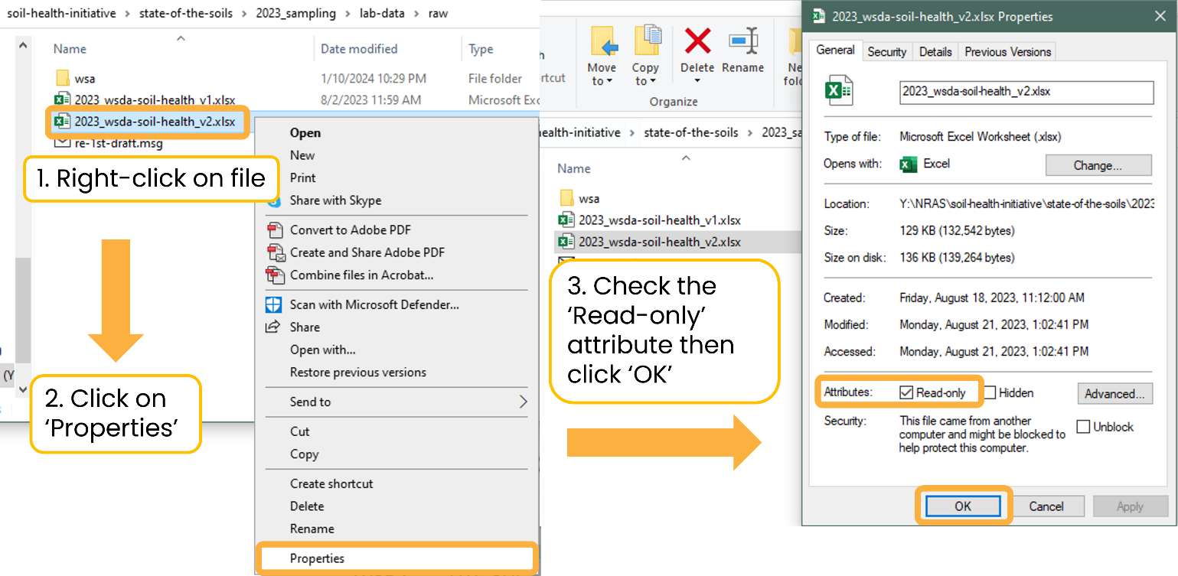

5.3 Version control with Git and GitHub
A version control system records changes to files over time. Git is a free and open-source distributed version control system. GitHub is the hosting site we use to interface with Git. Git and GitHub are fundamental to reproducible statistical and data scientific workflows (Bryan 2018).
Version control ensures changes are documented and previous versions are accessible if changes must be recalled. Additionally, version control enables robust collaboration across projects.
It’s useful for not only code projects, but also for documents, presentations, and books (like this DMP!). Git and GitHub automatically save the revision history of each file, so there is only a single name for each file (e.g., report.docx) instead of report_v01.docx and report_v02.docx. For a reminder on version naming, see Section 3.2.7).
The screenshot below shows who made commits (i.e., named version histories) and when they were made. From this screen, a user can click on the commit message to view all files that were changed.
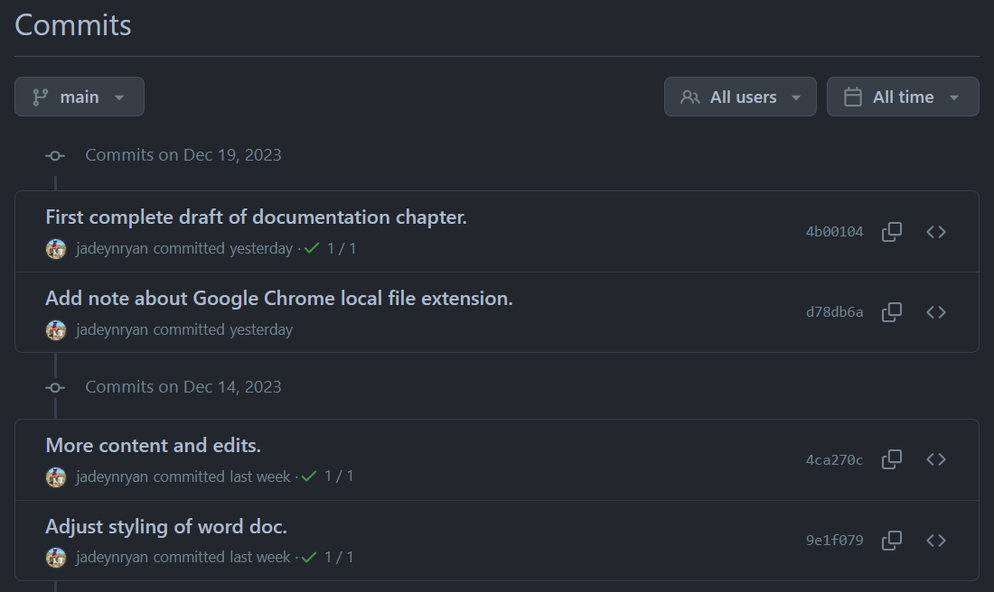
After clicking the first commit message, a diff (i.e., a visual of what changed) displays the changed file documentation.qmd with additions highlighted in green and deletions highlighted in red.
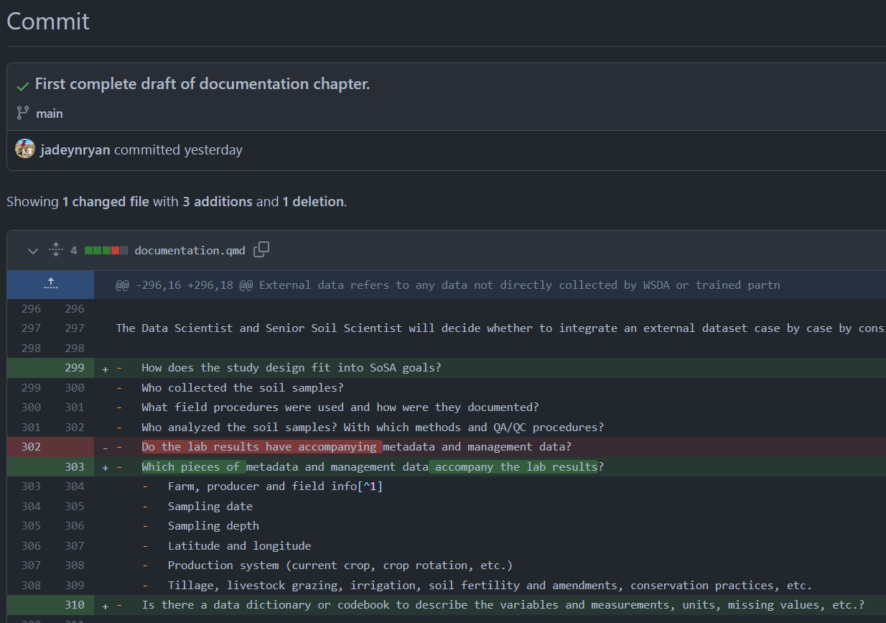

Privacy considerations
Review Chapter 8 to categorize the data included in the repository to protect grower privacy. If the data are not anonymized and aggregated, either 1) the repository must be set to private or 2) data files and any scripts containing Category 3 data as described in Section 8.1.0.2 must be added to the .gitignore file.

Git and GitHub resources
Review the Get Started with Git & GitHub slides and recording provided by the Data Scientist.
Read Jenny Bryan’s article Excuse Me, Do You Have a Moment to Talk About Version Control (open-access pre-print; full article on WSDA shared drive) for a background on Git and GitHub, why we should use it, and how to get started. For detailed instructions, follow along with her free online book Happy Git and GitHub for the useR.
GitHub: A Beginner’s Guide is a helpful resource created by Birds Canada for less advanced programmers. If you prefer to look through slides, see Byron C. Jaeger’s presentation Happier version control with Git and GitHub (and RStudio).

6. Documentation
Documentation is the process of recording all aspects of project design; sampling; lab analyses; data cleaning; data analyses; data quality control and assurance procedures; and development of decision-support tools. Seem familiar? These are the steps of the data life cycle. Documentation helps to:
- standardize procedures
- enable reproducibility
- establish credibility
- provide searchability
- ensure others (including our future selves) use and interpret data correctly
All documentation (including this document) should be updated (and versioned) as procedures change and lessons are learned. The below descriptions and examples were created for the SOS, though the principles apply to all data generated by the Climate & Conservation Team.
Samples collected by WSDA for the SOS must follow the procedures and standards described in the below documentation.
External data must have, at minimum, the documentation outlined in Section 6.4 to be integrated into the SOS dataset.

6.1 Project-level
Project-level documentation includes all descriptive information about the dataset, as well as planning decisions and process documentation. Documentation includes quality assurance project plans, standard operating procedures, and other high-level documents (e.g., request for proposals, applications, meeting agendas/notes).

Quality assurance project plan (QAPP)
The QAPP is the highest level of project documentation and covers everything from the project description; personnel roles and responsibilities; project timelines; data and measurement quality objectives; study design; and overviews of field, laboratory, and quality control.
The SOS QAPP can be found in Y:/NRAS/soil-health-initiative/state-of-the-soils/qapp.

Standard operating procedures (SOP)
SOPs provide detailed instructions for field, lab, or data processing procedures and decision-making processes.
The SOS SOPs can be found in Y:/NRAS/soil-health-initiative/state-of-the-soils/sop.

SOS sampling
The purpose of this SOP is to detail the procedures for a typical site visit in which soil samples are collected for physical, chemical, and biological soil health indicator analyses. Procedures include equipment preparation prior to sampling; best practices for filling out field forms; the selection of sampling locations; sampling protocols; sample handling and storage; and submitting samples to the lab. Following this SOP ensures data quality by creating audit trails and reminders to check that data are present, complete, and accurate. Additionally, this SOP will be used to maintain consistent sample collection procedures throughout the state for WSDA employees and partners.

Quality control / quality assurance (QA/QC)
This SOP outlines the process for screening sample metadata and lab results for completeness, consistency, and quality. Procedures involve subject matter expertise, investigation, communication with sampling teams and labs, algorithmic quality control, and tagging sample results with quality codes (listed in the below table). Data are then integrated into the statewide database.
Code | Tag | Description | Inclusion in analyses
0 | Excellent | Met lab’s and WSDA’s QC criteria | Yes
100 | Estimate | Interpolated missing value | Yes
110 | Derived | Derived from an estimated value | Yes
120 | Suspect | Z-score is ≥ |3| | Yes
130 | Calculated ND | Calculated value using at least one ND | Yes
140 | Non-detect | Below the method detection limit | No
160 | Poor | Did not meet lab’s QC criteria | No
180 | Outlier | Outlier, designated by soil scientist | No
200 | Unknown | External dataset | Yes
ND = non-detect

6.2 Dataset-level
Dataset-level documentation applies to lab results, sample locations, grower information, and management data. Readmes and changelogs document what each dataset contains, how they are related, potential issues to be aware of, and any alterations made to the data. See below for examples of what to include.
These files are saved as plain text (.txt) or markdown (.md) files, instead of MS Word documents that take longer to open and can only be opened/edited on computers with Microsoft installed.

Readme
readme files are plain text documents that contain information about the files in a folder, explanation of versioning, and instructions/metadata for data packages.

Describe contents of folder
The readme.txt in the _complete-dataset folder describes each file’s structure, contents, and other pertinent information, such as data sources.

Explain versions
The readme.txt in the 2023_sampling > lab-data > raw folder explains why there are two different versions of the lab results and where to find additional information.

Provide instructions
Another readme.txt instructs how to use the files in the ArcGIS soil sample points box.com folder. When this folder is shared with partners, the readme helps orient them to the contents of the folder and modify the files as needed for their own project.

Changelog
Changelogs are also simple and concise plain text documents saved in a folder alongside data files that document changes to the dataset. For more information, see keepachangelog.com/.
At the bare minimum, the changelog.txt contains:
- date of modification
- initials of who made the changes
- description of the changes
See the example changelog.txt in the _complete-dataset folder.

6.3 Variable-level
Variable-level documentation includes data dictionaries, which are tabular collections of names, definitions, and attributes about the variables in a dataset. Data dictionaries are ideally created in the planning phase of the project before data are collected.

Data dictionary
Each row is a different variable, and each column is a different attribute of that variable. With a data dictionary, a user should be able to properly interpret each variable in the data.
Our data-dictionary.xlsx in the _complete-dataset folder contains three tabs (lab-results, sample-locations, and qc-codes) that describe the attributes of each variable.

6.4 External data
External data refers to any data not directly collected by WSDA or trained partners (e.g., WSU or conservation districts) that follow our SOPs. These can include other studies pre-dating WaSHI, special soil health surveys, and publicly available datasets.
On a case-by-case basis, the Senior Soil Scientist and Data Scientist consider the following questions when deciding whether to integrate an external dataset:
- How does the study design fit into SOS goals?
- What field procedures were used and how were they documented?
- Who analyzed the soil samples? With which methods and QA/QC procedures?
- Are the following required metadata and management data available along with the lab results?
  - Farm, producer, and field info
  - Sampling date
  - Sampling depth
  - Latitude and longitude
  - Production system (current crop, crop rotation, etc.)
  - Information concerning tillage, livestock grazing, irrigation, soil fertility and amendments, land use history, and/or conservation practices
- Is there a data dictionary or codebook describing the measurements, units, missing values, etc.?
Generally, external data should 1) be well documented, 2) be collected and analyzed by well-trained scientists and labs; and 3) have adequate accompanying metadata and management data to facilitate interpretation of the results.
Some publicly available datasets to consider are in Y:/NRAS/soil-health-initiative/state-of-the-soils/external-data.

Intake form
External data may be provided in the External Data Intake spreadsheet, alongside related documents such as SOPs, management surveys, raw data files, etc.

7. Data flow
This chapter outlines how SOS data were generated, processed, and moved from start to finish. This flow generally applies to all field data generated by the Climate & Conservation Team.

7.1 Pre field season
When preparing sample ID assignments, labels, chain of custodies, and other materials, use an accessible font to reduce transcription errors. Atkinson Hyperlegible has very distinct alphanumeric characters, which improves legibility. Download it from Google Fonts.
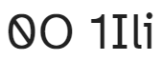
“0O” and “11li” in Atkinson Hyperlegible

Assign unique identifiers
Before sample IDs can be assigned, collect the following information for each proposed sample:
- County
- Organization of sampling team
- Farm name (optional)
- Producer name
- Producer contact information (optional)
- Field name
- Crop
- General management practice (i.e., conventional, cover crop, reduced tillage)
View examples of the 2024 Sample Request Form sent to conservation districts and the Berries Sample Request Form used for a WSDA/WSU special project.
Once producers and fields have been identified, assign a unique ID for the producer, field, and sample with the following convention:
- Producer ID: first three letters of county + three-digit landowner number
  - WHA001
- Field ID: two-digit field number
  - 01 and 02
- Pair ID (optional): letter extension added to paired fields
  - A
- Sample ID: last two digits of year + Producer ID + Field ID + Pair ID
  - 24-WHA001-01-A and 24-WHA001-02-A
The following counties have different abbreviations than their first three letters:
- Clallam → CLL
- Grays Harbor → GRY
- Kitsap → KIS
- Skamania → SKM
Match producer and field IDs to previous participants. Continue the sequence for new producers and fields. Producer IDs and sample IDs must not be duplicated.
For an example R script to automate this process, see assign-sample-ids.R.

Create sample labels
Sample label creation is automated using R and Microsoft Word’s mail merge tool. labels.R generates a spreadsheet with the information to be printed on the labels. Then open labels-template-mail-merge.docx, select the spreadsheet as the recipient list, and run the mail merge to generate a word document with all labels to be printed (as shown in the completed-labels folder).

Create a data tracking sheet
Create a spreadsheet to track which data have been submitted for each sample, including:
- GPS points through the ArcGIS Field Maps field form
- Scanned paper field forms (for those without ArcGIS Field Maps)
- Management surveys through ArcGIS Survey123
- Scanned chain of custodies with shipping tracking numbers
- Location of archival falcon tubes (once retrieved by WSDA staff)
- Notes for changed samples (i.e., different sample ID, crop, or field) or samples that were not collected
See the 2023 spreadsheet for an example.

Develop ArcGIS web tools
Use ArcGIS to build tools for managing spatial data and collecting management survey data.
- In ArcGIS Pro, create a sample selection feature layer with domains for point numbers, bulk density, and crop types. Publish this feature layer to ArcGIS Online as a web map with a soil series layer. Then publish a second copy without the soil series layer and enable offline use.
- On ArcGIS Online, use Field Maps to configure the field form for the feature layer. Management surveys are created and hosted with Survey123 and Experience Builder. Schedule the ArcGIS Notebook with Python that backs up all data to run as a task every Monday, Wednesday, and Friday during the field season.
This template ArcGIS Pro project includes a readme.txt that describes this process.
View the code from the ArcGIS Notebook on the website version of this DMP.

7.2 During field season
Data collection in the field is detailed in the sampling SOP. Here, we focus on the behind-the scenes tasks for managing data.

Update data tracking spreadsheet
Throughout the season, update the data tracking spreadsheet as various forms, surveys, and correspondence are received, as described in Create a data tracking sheet.

Modify IDs when samples change
Sometimes a producer can no longer participate, or they need to change which field is sampled. Update, version, and archive the sample request form (sample-request-form-ferry.xlsx → sample-request-form-ferry_v2.xlsx). Run the assign-sample-ids.R script again to update the sample IDs. Lines 362 - 386 should be commented out as shown in the highlighted lines of the script on GitHub.
See 01_returned-sample-requests and 02_completed-sample-ids for an example of this flow.
Add a concise, explanatory note to the data tracking spreadsheet.

7.3 Post field season

Organize multiple sources of data
To unify the information from multiple data sources (e.g., sample request forms, ArcGIS Field Maps forms, and management surveys), cross-reference each source and reach out to the sampling teams to resolve conflicting information as needed. This is especially important for verifying the crop planted at the time of sampling.
See how to mostly automate this in: 01_load-metadata.R and 02_check-crops.R.

Process lab data
Follow the QA/QC SOP for processing lab data.
See the 2024 processing scripts and QA/QC report on GitHub:
- 03_process-spatial-data.R
- 04_load-lab-data.R
- 05_save-complete-dataset.R
- 06_calculate-z-scores.R
- 2020-2024_qc-results-summary.qmd

Generate reports
Use the {soils} package to create a new project for each year. To avoid email attachment size limitations, save reports to Box.com for distribution to the sampling partners who send the reports to the participants. Access to this folder requires a share link provided by WSDA staff.

Save data to shared drive and WSU Teams channel
Copy the output data files and reports from Process lab data and Generate reports to the state-of-the-soils folder in its respective year_sampling folder. See Chapter 4 to review folder structure and organization.
Save the final datasets (in wide and long formats) and documentation (data dictionary, changelog, readme) to the WSU SCBG Soil Health Assessment Teams channel.

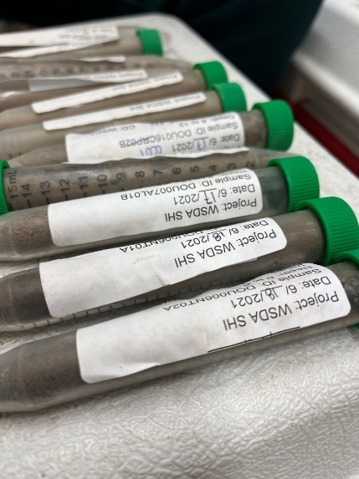
Archive jars and falcon tubes
Store the archival subsamples in glass jars in the Yakima WSDA storage room and the cryogenic archive subsamples in falcon tubes in the -80 °C freezer at the WSU Mount Vernon Northwestern Washington Research & Extension Center.
Tape the labels on the falcon tubes with a generous amount of packing tape to avoid falling off when they freeze.
Update the archive spreadsheet with the additional sample IDs, number of falcon tubes, and box number of the glass jar.

8. Data sharing
Our data sharing policies promote FAIR principles so our data are “as open as possible, as closed as necessary” (European Commission 2016). Data should be open enough to facilitate efficient re-use; avoid duplicating data collection efforts; enhance scholarly rigor; and promote engagement across the research and public communities (Whyte and Pryor 2011). However, data must also be closed enough to protect grower privacy and to honor agreements with growers and other researchers (Czarnecki and Jones 2022; Korzekwa 2023).
Our work relies on growers’ willingness to volunteer their time, knowledge, and access to their fields. Their willingness depends on their trust in us to protect their privacy. Only aggregated and anonymized results will be publicly available or shared.

Data privacy statement
The below statement was provided to SOS participants and may be modified/shared with potential participants of other data generating projects.
All survey responses will be combined across all respondents. Results will not be reported in a way that makes individuals identifiable. Information collected in this survey are subject to release in accordance with RCW 42.56 (Public Records Act).
Procedures for anonymizing data are detailed in Section 8.2.

8.1 WaTech data categorization
Under Washington State Policy 141.10 (Securing Information Technology Assets), state agencies must classify data into categories based on the sensitivity of the data. WaTech provides guidance on the four categories of data.

Category 4: “Confidential information requiring special handling”
WaTech: Data requires strict handling requirements applied by statues or regulations.
SOS: Not applicable.

Category 3: “Confidential information”
WaTech: Data includes “personal information” as defined in RCW 42.56.590 (Security Breaches) and RCW 19.255.010 (Personal Information Disclosure). An individual’s first name or first initial and last name in combination with at least one of the following elements: social security number, driver’s license or Washington identification card number, or any account numbers that permit access to their financial account.
SOS: We do not collect the above elements in combination with grower names. However, we treat individual names, farm names, and latitude and longitude coordinates as confidential information.

Category 2: “Sensitive information”
WaTech: Data are intended for official use only and withheld unless specifically requested.
SOS: This category includes lab results and management surveys. Access to this data requires a data share agreement.

Category 1: “Public information”
WaTech: Data is not covered in any of the above categories or is already released to the public.
SOS: De-identified and aggregated data, such as the number of soil samples and from which counties and crops they were collected, fall under this category. For example, the SOS dashboard is publicly available and the map zoom is disabled at the 1:1,600,000 scale (counties level).

8.2 Maintain confidentiality
Only under special circumstances and with proper justification in the data share agreement will the following Category 3 data be released to external collaborators. Under no circumstances will these data be made publicly available.
- Farm name
- Grower first and last name
- Field names that contain street names or other identifying information
- Latitude and longitude coordinates or other geospatial identifiers
- Any information identifying the individual farm or grower
Anonymize and aggregate Category 2 data to honor our data privacy statement by either removing or replacing Category 3 confidential information with dummy data. The {randomNames} R package can be used to replace real names with fake names. Round latitude and longitude to a precision that does not identify the farm or fields sampled.
See an example R script that anonymizes data on the website version of this DMP.

8.3 Data share agreement
SOS CoPIs created a Data Sharing and Scope of Work Agreement detailing the type of data to be shared, the scope of work in which the data may be used, and terms for using SOS data.
Once both CoPIs and the “Partnering Scientists” sign the agreement, save it in its own subfolder within the washi-sos/data-sharing GitHub folder. Include relevant correspondence, code to subset the requested data, and final dataset in the agreement’s subfolder. This documentation allows us to track publications, attributions, and the broader impact of the SOS dataset.

8.4 Public access
Currently, the only publicly available SOS data are the counts of samples across the project, counties, and crop types displayed in the ArcGIS Online Dashboard.
A small, anonymized subset is included as example data in the {washi} and {soils} R packages for demonstration purposes.
When the data are more mature and hosted in a proper database, we may publish an anonymized subset in a public repository such as:
- GitHub via an R package or Shiny app
- Zenodo: integrates with GitHub and is citable with a DOI
- Data.WA.gov: open data portal for the State of Washington
More inspiration for enhancing data discoverability and sharing across the agricultural and soil health communities include:
- USDA LTAR data dashboards
- CAF LTAR metadata tool
Chapter 16 of Data Management in Large-Scale Education Research discusses more considerations for data sharing and choosing public repositories (Lewis 2023).

8.5 Acknowledgments
All research and data partially or completely funded by WaSHI must include acknowledgements to the State of Washington. The following text should be included in all publications resulting from this funding:
Data were in part provided by the Washington Soil Initiative, which is supported by the State of Washington and administered by the Washington State Department of Agriculture, Washington State Conservation Commission, and Washington State University.
If WaSHI staff make substantial scientific contributions to the manuscript, discuss the possibility of co-authorship credit.

9. Code style guide
This style guide adapts the Tidyverse Style Guide and incorporates best practices from R for Data Science (2e) (R4DS), Data Management in Large-Scale Education Research, and other resources.
All staff who code in R should thoroughly read and consistently implement this style guide.
Using consistent project structures, naming conventions, script structures, and code style will improve code readability, reproducibility, and ease of collaboration.
Good coding style is like correct punctuation: you can manage without it, butitsuremakesthingseasiertoread…
All style guides are fundamentally opinionated. Some decisions genuinely do make code easier to use (especially matching indenting to programming structure), but many decisions are arbitrary. The most important thing about a style guide is that it provides consistency, making code easier to write because you need to make fewer decisions.
- Hadley Wickham in the Tidyverse Style Guide

9.1 Projects
Keep all files associated with a given project (input data, R scripts, analytical results, figures, reports) together in one directory. RStudio has built-in support for this through projects, which bundle all files in a portable, self-contained folder that can be moved around on your computer or on to other collaborators’ computers without breaking file paths.
Create a GitHub repository and commit the project folder for version control as discussed in Section 5.3. If not in a GitHub repository, the folder must be copied onto the shared drive.
Learn more about projects in the Workflow: scripts and projects chapter of R4DS, in Jenny Bryan’s article Project-oriented workflow, and Shannon Pileggi’s workshop slides.

Project folder structure
A consistent and logical folder structure makes it easier for you (especially future you) and collaborators to make sense of the files and work you’ve done. Well documented projects also make it easier to resume a project after time away.
The below structure works most of the time and should be used as a starting point. However, different projects have different needs, so add and remove subfolders as needed.
- root: top-level project folder containing the .Rproj file
- data: contains raw and processed data files in subfolders. Raw data should be made read-only and not changed in any way. Review Section 5.2 for how to make a file read-only
- output: outputs from R scripts such as figures or tables
- R: R scripts containing data processing or function definitions
- reports: Quarto or RMarkdown files with the resulting reports
- README: markdown file (can be generated from Quarto or RMarkdown) explaining the project
R packages, such as {washi} and {soils}, contain additional subfolders and files:
- inst: additional files to be included with package installation such as CITATION, fonts, and Quarto templates.
- man: .Rd (“R documentation”) files for each function generated from {roxygen2}.
- vignettes: long-form guides that go beyond function documentation and demonstrate a workflow to solve a particular problem
- tests: test files, usually using {testthat}
- pkgdown and docs: files and output if using {pkgdown} to build a website for the package
- DESCRIPTION: file package metadata (authors, current version, dependencies)
- LICENSE: file describing the package usage agreement
- NAMESPACE: file generated by {roxygen2} listing functions imported from other packages and functions exported from your package
- NEWS.md: file documenting user-facing changes
Learn more about other R package components in R Packages (2e).

Absolute vs relative paths
Note
Directories and folders are used interchangeably here. If you’re interested in the technical differences, directories contain folders and files to organize data at different levels while folders hold subfolders and files in a single level.
❌ Absolute paths start with the root directory and provide the full path to a specific file or folder like C:\\Users\\jryan\\Documents\\R\\projects\\project-demo\\data\\processed. Run getwd() to see where the current working directory is and setwd() to set it a specific folder. However, a working directory set to an absolute folder path will break the code if the folder is moved or renamed
✅ Instead, always use relative paths, which are relative to the working directory (i.e. the project’s home) like data/processed/data-clean.csv. When working in an RStudio project, the default working directory is the root project directory (i.e., where the .Rproj file is).
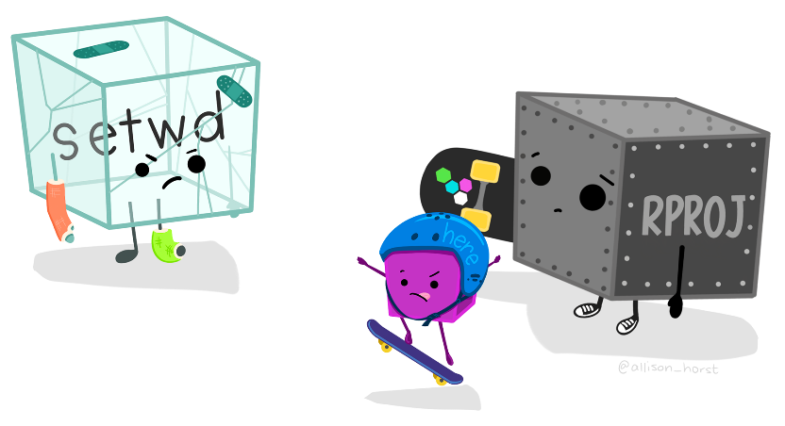
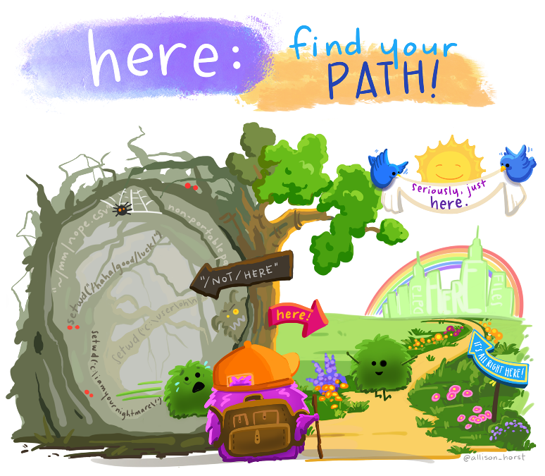
Artwork by Allison Horst
Artwork by Allison Horst

{here} package
In combination with R projects, the {here} package builds relative file paths. This is especially important when rendering Quarto files because the default working directory is where the .qmd file lives. Using the above example project structure, running read.csv("data/processed/data-clean.csv") in soil-health-report.qmd errors because it looks for a data subfolder in the reports folder. Instead, use here to build a relative path from the project root with read.csv(here::here("data", "processed", "data-clean.csv")). This takes care of the backslashes or forward slashes so the relative path works with any operating system.

9.2 Naming conventions
“There are only two hard things in Computer Science: cache invalidation and naming things.”
— Phil Karlton
Based on this quote, Indrajeet Patil developed a slide deck with detailed language-agnostic advice on naming things in computer science.
R code specific naming conventions are listed below. Python and other programming languages have different conventions.

Project folder, .RProj and GitHub repository
Name the project folder, .RProj file, and GitHub repository name the same. Be concise and descriptive. Use kebab-case.
Example: washi-dmp and washi-dmp.RProj.

Files
Be concise and descriptive. Avoid using special characters. Use kebab-case with underscores to separate different metadata groups (e.g., year_good-name).
Examples: 2024_producer-report.qmd, tables.R, create-soils.R.
If files should be run in a particular order, prefix them with numbers. Left pad with zeros if there may be more than 10 files.
Example:
01_import.R
02_tidy.R
03_transform.R
04_visualize.R

Variables, objects, and functions
Variables are column headers in spreadsheets (that become column names in R dataframes), objects are data structures in R and ArcGIS (vectors, lists, dataframes, fields, tables), and functions are self-contained modules of code that accomplish a specific task.
Variable examples:
# Good
clay_percent
min_c_96hr_mg_c_kg_day
pmn_mg_kg
# Bad
# Uses special character
clay_%
# Less human readable, inconsistent with style guide,
# starts with number and will error in R
96hrminc_mgckgday
# Hyphen will need to be escaped in R code to avoid error
pmn-mgkg

Objects and functions
Objects names should be nouns, while function names should be verbs (Wickham 2022). Use lowercase letters, numbers, and underscores. Do not put a number as the first character of the name. Do not use hyphens. Do not use names of common functions or variables.
Object examples:
# Good
primary_color
data_2023
# Bad
# Less human readable, inconsistent with style guide
primarycolor
# Using a hyphen in an object name causes error
data-2023 <- read.csv("2023_data-clean.csv")
Error in data - 2023 <- read.csv("2023_data-clean.csv") :
could not find function "-<-"
# Starting an object name with a number also causes error
2023_data <- read.csv("2023_data-clean.csv")
Error: unexpected input in "2023_"
# Overwrites R shortcut for TRUE
T <- FALSE
# Overwrites c() R function
c <- 10
Function examples:
# Good
add_row()
assign_quality_codes()
# Bad
# Uses noun instead of verb
row_adder()
# Inconsistent with style guide
assignQualityCodes()
# Overwrites common base R function
mean()

9.3 R scripts

Header template
Headers in R scripts standardize the metadata elements at the beginning of your code and document its purpose. The following template and instructions are adapted from Dr. Timothy S Farewell’s blog post (Farewell 2018).
- Script name: meaningful and concise
- Purpose: brief description of what the script aims to accomplish
- Author(s) and email: name and contact if there are any questions
- Date created: automatically filled in from the template
- Notes: space for thoughts or to-do’s
## Header ======================================================================
## Script name: check-crops.R
##
## Purpose: Cross reference sample requests, Field Maps forms, and management
## surveys to get the correct crop planted at the time of sampling.
##
## Author: Jadey Ryan
##
## Email: jryan@agr.wa.gov
##
## Date created: 2024-01-02
##
## Notes:
##
# Attach packages ==============================================================
library(readxl)
library(writexl)
library(janitor)
library(dplyr)
library(tidyr)
# Load data ====================================================================
Add this template to RStudio using snippets:
- Modify the below code with your name and preferred packages.
- In RStudio, go to Tools > Edit Code Snippets.
- Scroll to the bottom of the R code snippets and paste your modified code (the indent and tabs are important!).
- Click Save and close the window.
- Try opening a new blank .R script, typing “header”, and then pressing Shift + Tab.
snippet header
## Header =====================================================================
##
## Script name:
##
## Purpose:
##
## Author: Jadey Ryan
##
## Email: jryan@agr.wa.gov
##
## Date created: `r paste(Sys.Date())`
##
## Notes:
##
# Attach packages =============================================================
library(readxl)
library(writexl)
library(janitor)
library(dplyr)
library(tidyr)
# Load data ===================================================================

Section template
The above header template also uses section breaks (e.g., commented lines with = that break up the script into easily readable chunks). Section breaks are a fantastic tool in RStudio because they allow you to easily show or hide blocks of code, see an outline of your script, and navigate through the source file. Read more about code folding and sections in this Posit article.
The snippet to create this section template that fills in the rest of the line with = or - was adapted from this stack overflow answer.
snippet end=
`r strrep("=", 85 - rstudioapi::primary_selection(rstudioapi::getActiveDocumentContext())$range$start[2])`
snippet end-
`r strrep("-", 85 - rstudioapi::primary_selection(rstudioapi::getActiveDocumentContext())$range$start[2])`
After adding the above code to your snippets, try creating a new section by typing “# Tidy data end=” then pressing Shift + Tab.
# Tidy data end=<Shift+Tab> results in:
# Tidy data ====================================================================
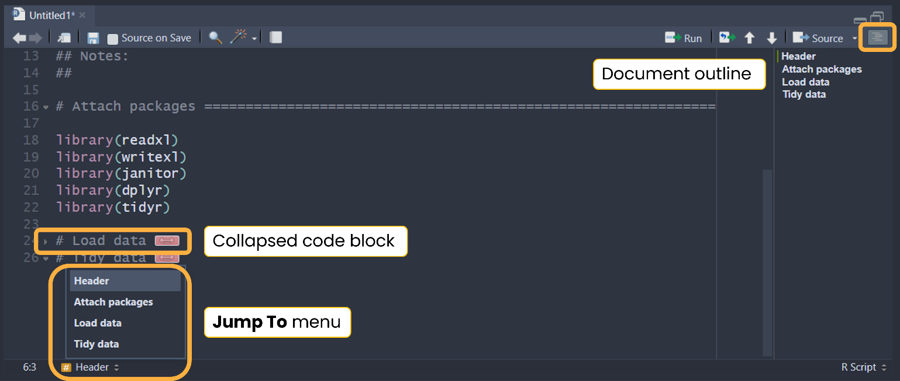

9.4 Code styling
Review the Syntax chapter of the Tidyverse Style Guide for details on spacing, function calls, long lines, semicolons, assignments, comments, and more. For the opinionated “most important parts of the Tidyverse Style Guide,” skim through Chapter 4 Workflow: code style in R4DS. Instead of including each detail in this style guide and memorizing the content, use the {styler} package (as advised in R4DS Chapter 4).
{styler} includes an RStudio addin that automatically formats code, making the style consistent across projects. We deviate slightly from the Tidyverse Style Guide and instead use {grkstyle}, an extension package developed by Garrick Aden-Buie, that handles line breaks inside function calls and indentation of function arguments differently. See the readme for examples.

Set up {styler} and {grkstyle}
Install {styler} and {grkstyle} with:
install.packages("styler")
options(repos = c(
gadenbuie = "https://gadenbuie.r-universe.dev",
getOption("repos")
))
# Download and install grkstyle in R
install.packages("grkstyle")
Set grkstyle as the default in {styler} functions and addins with:
# Set default code style for {styler} functions
grkstyle::use_grk_style()
or add the following to your ~/.Rprofile:
options(styler.addins_style_transformer = "grkstyle::grk_style_transformer()")
Access your .Rprofile with usethis::edit_r_profile() to open the file in RStudio for editing. You may need to install the {usethis} package.

Use {styler} and {grkstyle}
Once installed, apply the style to .R, .qmd, and .Rmd files using the command palette, keyboard shortcut, or addins menu.

Command palette
Use RStudio’s command palette to quickly and easily access any RStudio command and keyboard shortcuts. Open the command palette with Cmd/Ctrl + Shift + P then type “styler” to see its available commands and shortcuts.

Keyboard shortcuts
Use Cmd/Ctrl + Shift + A to style the entire active file. We recommend styling the entire active file after finishing each code block or section. To style just a selection, use Cmd/Ctrl + Alt + Shift + A.

Addins menu
Use the addins menu in RStudio to style code by clicking a button to run the command.
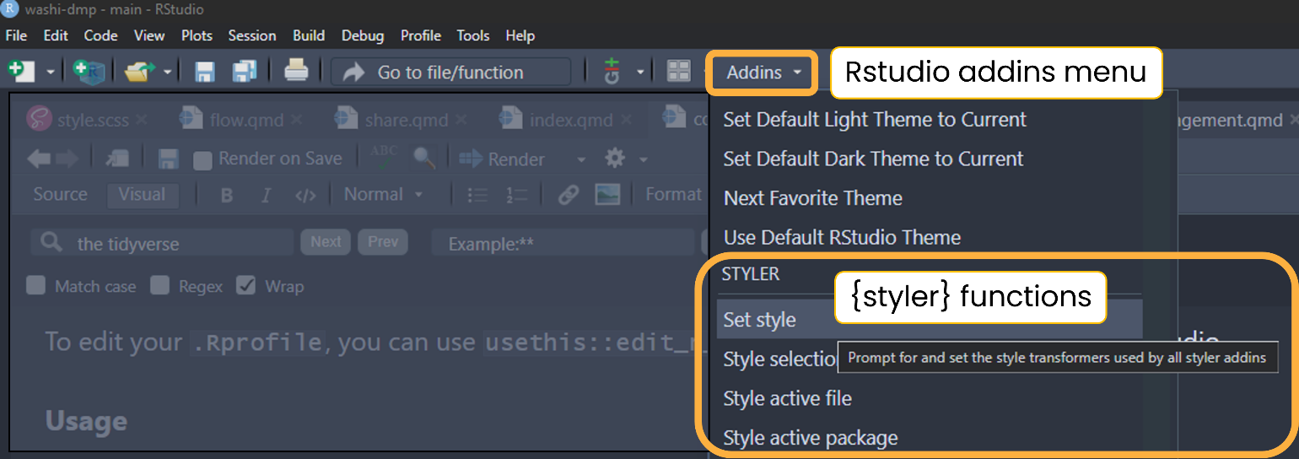

Set up and use {air}
{air} is an R formatter that is even faster and more automatic than {styler}. It needs to be installed through the command line interface (see installation instructions) then configured in RStudio (see configuration instructions. It can be set to reformat documents on save. The downside to {air} over {styler} is that it does not currently work on Quarto (.qmd) files.

References
Bryan, Jennifer. 2018. “Excuse Me, Do You Have a Moment to Talk about Version Control?” The American Statistician 72 (1): 20–27. https://doi.org/10.1080/00031305.2017.1399928.
Carlson, Bryan. 2021. “Data Management Plan for the R.J. Cook Agronomy Farm Long-Term Agroecological Research Site.”
Czarnecki, Joby M. Prince, and Mary Ann Jones. 2022. “The Problem with Open Geospatial Data for on-Farm Research.” Agricultural & Environmental Letters 7 (1): e20062. https://doi.org/10.1002/ael2.20062.
European Commission. 2016. “H2020 Programme Guidelines on FAIR Data Management in Horizon 2020.” https://ec.europa.eu/research/participants/data/ref/h2020/grants_manual/hi/oa_pilot/h2020-hi-oa-data-mgt_en.pdf.
Farewell, Dr Timothy S. 2018. “My Easy r Script Header Template Tim Farewell.” https://timfarewell.co.uk/my-r-script-header-template/.
Harvard Medical School. 2023. “Data Management Plans.” https://datamanagement.hms.harvard.edu/plan-design/data-management-plans.
Korzekwa, Kaine. 2023. “Protecting Privacy While Making Data Open in Agricultural Research.” CSA News 68 (3): 6–10. https://doi.org/10.1002/csan.20979.
Lewis, Crystal. 2023. Data Management in Large-Scale Education Research [in Preparation]. https://datamgmtinedresearch.com/.
U.S. Fish & Wildlife Service. 2023. “Data Management Life Cycle.” https://www.fws.gov/program/data-management/data-management-life-cycle.
Whyte, Angus, and Graham Pryor. 2011. “Open Science in Practice: Researcher Perspectives and Participation.” International Journal of Digital Curation 6 (March): 199–213. https://doi.org/10.2218/ijdc.v6i1.182.
Wickham, Hadley. 2022. The Tidyverse Style Guide. https://style.tidyverse.org/index.html.
Wilkinson, Mark D., Michel Dumontier, IJsbrand Jan Aalbersberg, Gabrielle Appleton, Myles Axton, Arie Baak, Niklas Blomberg, et al. 2016. “The FAIR Guiding Principles for Scientific Data Management and Stewardship.” Scientific Data 3 (1): 160018. https://doi.org/10.1038/sdata.2016.18.

Enough farm, producer and field info should be provided to distinguish unique farmers and fields for assigning unique IDs. They don’t need to include personally identifiable information.
Note the two backslashes. Windows paths use backslashes, which mean something specific in R. To make Windows paths with backsplashes work, replace them with two backslashes or one forward slash.

